**Project Design Phase-II**

**Technology Stack (Architecture & Stack)**

|  |  |
| --- | --- |
| Date | 03 October 2022 |
| Team ID | PNT2022TMID15315 |
| Project Name | Web Phishing Detection |
| Maximum Marks | 4 Marks |

**Technical Architecture:**

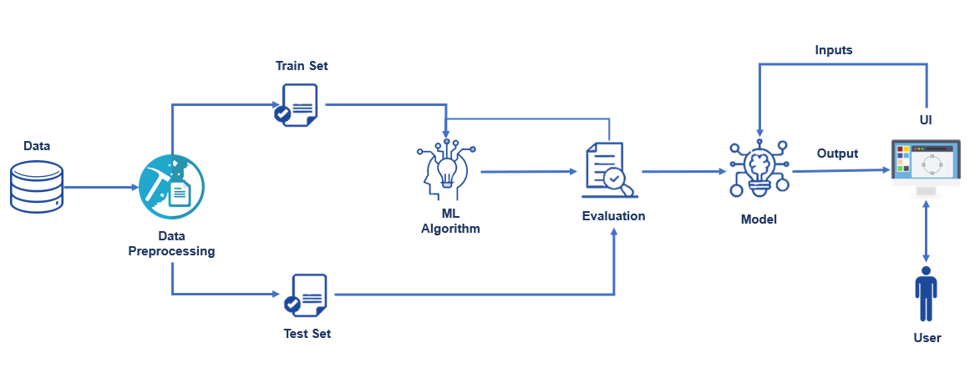

**Table-1 : Components & Technologies:**

|  |  |  |  |
| --- | --- | --- | --- |
| **S.No** | **Component** | **Description** | **Technology** |
|  | Application Logic-1 | Logic for a process in the application | Python |
|  | Application Logic-2 | Logic for a process in the application | IBM Watson STT service |
|  | Application Logic-3 | Logic for a process in the application | IBM Watson Assistant |
|  | Database | Data Type, Configurations etc. | MySQL, NoSQL, etc. |
|  | Cloud Database | Database Service on Cloud | IBM DB2, IBM Cloud ant etc. |
|  | File Storage | File storage requirements | IBM Block Storage or Other Storage Service or Local Filesystem |
|  | Machine Learning Model | Purpose of Machine Learning Model | Object Recognition Model, etc. |
|  | Infrastructure (Server / Cloud) | Application Deployment on Local System / Cloud  Local Server Configuration:  Cloud Server Configuration : | Local, Cloud Foundry, Kubernetes, etc. |

**Table-2: Application Characteristics:**

| **S.No** | **Characteristics** | **Description** | **Technology** |
| --- | --- | --- | --- |
|  | Open-Source Frameworks | Open-source phishing framework that makes it easy to test your organization's exposure to phishing. | Go phish, Speed Phish Framework (SPF), King Phisher, etc. |
|  | Security Implementations | Security / access controls implemented, use of firewalls etc. | e.g. anti-phishing protection and anti-spam software etc. |
|  | Scalable Architecture | Scalability detection and Isolation of phishing. | Response time, Throughput, CPU and network usages, etc. |
|  | Performance | Design consideration for the performance of the application and methods for detecting phishing attacks. | Blacklists/whitelists, Natural language Processing, Visual similarity, rules, machine learning techniques, etc**.** |